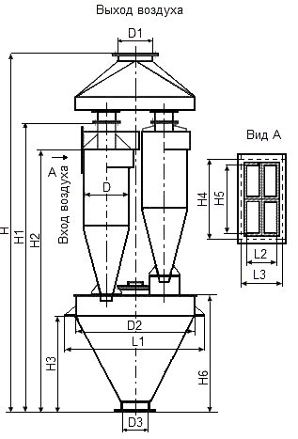

|  |  |  |  |  |  |  |  |  |
| --- | --- | --- | --- | --- | --- | --- | --- | --- |
| **Наименование** | **Q=м. куб/ч** | **D** | **D1** | **D2** | **D3** | **H** | **H1** | **H2** |
| **СЦН-40-300х4** | 1630-1930 | 300 | 237 | 660 | 300 | 2209 | 1774 | 1576 |
| **СЦН-40-400х4** | 2890-3430 | 400 | 317 | 860 | 300 | 2823 | 2324 | 2086 |
| **СЦН-40-500х4** | 4520-5370 | 500 | 377 | 1050 | 300 | 3511 | 2933 | 2637 |
| **СЦН-40-600х4** | 6500-7730 | 600 | 530 | 1250 | 300 | 4200 | 3583 | 3248 |
| **СЦН-40-700х4** | 8950-10630 | 700 | 530 | 1440 | 300 | 4774 | 4111 | 3738 |
| **СЦН-40-800х4** | 11570-13740 | 800 | 630 | 1660 | 300 | 5556 | 4720 | 4289 |
| **СЦН-40-900х4** | 14650-17400 | 900 | 720 | 1860 | 300 | 6255 | 5343 | 4859 |
| **СЦН-40-1000х4** | 18100-21480 | 1000 | 820 | 2060 | 300 | 6916 | 5928 | 5369 |
| **СЦН-40-1100х4** | 21900-26000 | 1100 | 920 | 2270 | 300 | 7444 | 6384 | 5801 |
| **СЦН-40-1200х4** | 25880-30730 | 1200 | 920 | 2470 | 300 | 8048 | 6904 | 6261 |
|  |  |  |  |  |  |  |  |  |
| **Наименование** | **H3** | **H4** | **H5** | **H6** | **L1** | **L2** | **L3** | **Масса, кг** |
| **СЦН-40-300х4** | 440 | 268 | 232 | 644 | 866 | 100 | 136 | 260 |
| **СЦН-40-400х4** | 610 | 344 | 308 | 844 | 1066 | 132 | 168 | 400 |
| **СЦН-40-500х4** | 780 | 428 | 384 | 1085 | 1256 | 164 | 208 | 570 |
| **СЦН-40-600х4** | 950 | 508 | 462 | 1385 | 1448 | 198 | 244 | 1070 |
| **СЦН-40-700х4** | 1130 | 584 | 538 | 1565 | 1658 | 230 | 276 | 1400 |
| **СЦН-40-800х4** | 1310 | 660 | 614 | 1806 | 1868 | 262 | 308 | 1720 |
| **СЦН-40-900х4** | 1480 | 748 | 690 | 2066 | 2070 | 294 | 350 | 2370 |
| **СЦН-40-1000х4** | 1530 | 824 | 766 | 2266 | 2270 | 326 | 384 | 2890 |
| **СЦН-40-1100х4** | 1560 | 908 | 846 | 2386 | 2482 | 363 | 424 | 4560 |
| **СЦН-40-1200х4** | 1680 | 984 | 922 | 2536 | 2682 | 394 | 456 | 5350 |