**Циклон СЦН-50-2УП с бункером**

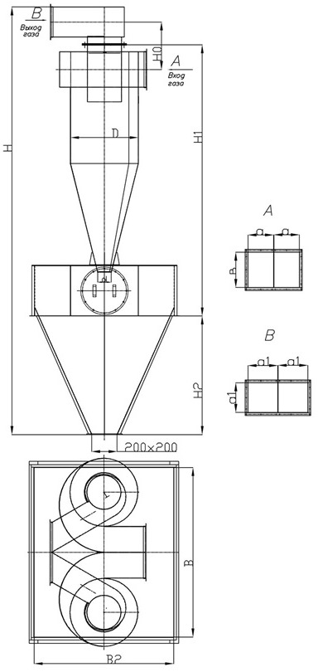

|  |  |  |  |  |  |  |  |  |  |
| --- | --- | --- | --- | --- | --- | --- | --- | --- | --- |
| **Наименование** | **Q=м. куб/ч** | **D** | **H/H1** | **H2** | **B** | **B2** | **d** | **V=м3** | **масса, кг** |
| **ЦИКЛОН СЦН-50-400х2** | 2260-3164 | 400 | 3170/1830 | 870 | 1100 | 1100 | 200 | 1,03 | 322 |
| **ЦИКЛОН СЦН-50-500х2** | 3520-4946 | 500 | 3810/2155 | 1080 | 1300 | 1300 | 200 | 1,56 | 464 |
| **ЦИКЛОН СЦН-50-600х2** | 5086-7120 | 600 | 4230/2480 | 1080 | 1300 | 1300 | 200 | 4,56 | 530 |
| **ЦИКЛОН СЦН-50-700х2** | 6924-9692 | 700 | 4980/2810 | 1400 | 1600 | 1600 | 200 | 2,64 | 779 |
| **ЦИКЛОН СЦН-50-800х2** | 9044-12660 | 800 | 5400/3130 | 1400 | 1600 | 1600 | 200 | 2,64 | 871 |
| **ЦИКЛОН СЦН-50-900х2** | 11446-16024 | 900 | 6430/3455 | 2000 | 2100 | 2100 | 200 | 5,45 | 1350 |
| **ЦИКЛОН СЦН-50-1000х2** | 14130-19782 | 1000 | 6850/3780 | 2000 | 2100 | 2100 | 200 | 5,45 | 1468 |
| **ЦИКЛОН СЦН-50-1200х2** | 20348-28486 | 1200 | 7500/4430 | 2000 | 2400 | 2400 | 200 | 7,07 | 1741 |