**Циклон СЦН-50-4УП с общим бункером**

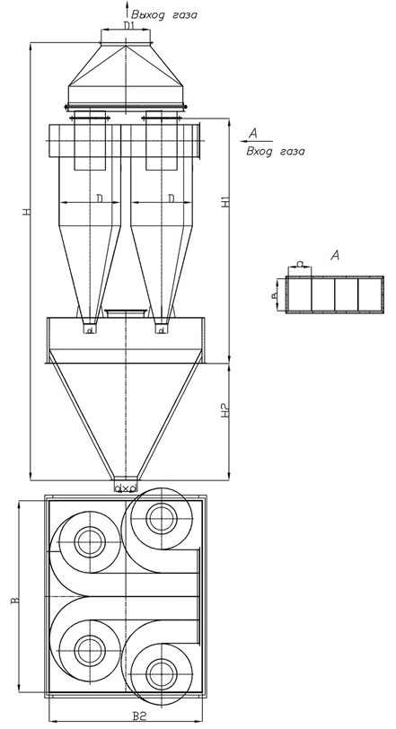

|  |  |  |  |  |  |  |  |  |  |
| --- | --- | --- | --- | --- | --- | --- | --- | --- | --- |
| **Наименование** | **Q=м. куб/ч** | **D** | **H/H1** | **H2** | **B** | **B2** | **D/d** | **V=м3** | **масса, кг** |
| **ЦИКЛОН СЦН-50-400х4** | 4520-6328 | 400 | 3170/1830 | 860 | 1100 | 1100 | 400/200 | 1,03 | 501 |
| **ЦИКЛОН СЦН-50-500х4** | 7040-9892 | 500 | 4100/2155 | 1400 | 1600 | 1600 | 550/200 | 2,64 | 885 |
| **ЦИКЛОН СЦН-50-600х4** | 10172-14240 | 600 | 4600/2480 | 1400 | 1600 | 1600 | 600/200 | 2,64 | 1061 |
| **ЦИКЛОН СЦН-50-700х4** | 13848-19384 | 700 | 5550/2810 | 2000 | 2100 | 2100 | 700/200 | 5,45 | 1606 |
| **ЦИКЛОН СЦН-50-800х4** | 18088-25320 | 800 | 6050/3130 | 2000 | 2100 | 2100 | 800/200 | 5,45 | 1842 |
| **ЦИКЛОН СЦН-50-900х4** | 22892-32048 | 900 | 6375/3455 | 2000 | 2400 | 2400 | 900/200 | 7,07 | 2201 |
| **ЦИКЛОН СЦН-50-1000х4** | 28260-39564 | 1000 | 7400/3780 | 2500 | 2600 | 2600 | 1000/200 | 9,48 | 2795 |
| **ЦИКЛОН СЦН-50-1200х4** | 40696-56972 | 1200 | 8050/4430 | 2500 | 3100 | 3100 | 1000/200 | 13,36 | 3692 |