**Циклон СЦН-50-6УП с общим бункером**

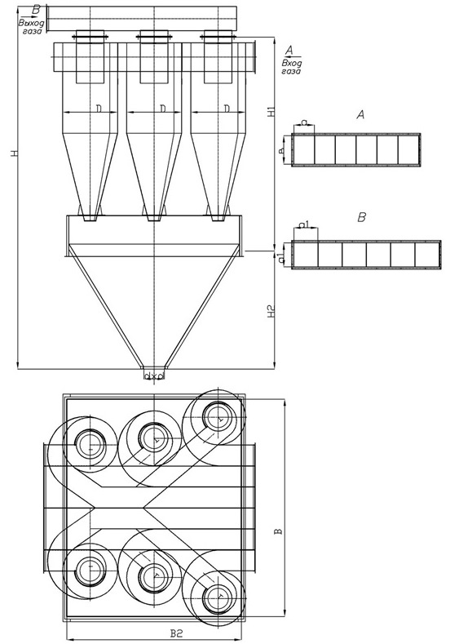

|  |  |  |  |  |  |  |  |  |  |
| --- | --- | --- | --- | --- | --- | --- | --- | --- | --- |
| **Наименование** | **Q=м. куб/ч** | **D** | **H/H1** | **H2** | **B** | **B2** | **d** | **V=м3** | **масса, кг** |
| **ЦИКЛОН СЦН-50-500х6** | 10560-14838 | 500 | 4230/2155 | 1400 | 1790 | 1600 | 200 | 2,95 | 1109 |
|  |
| **ЦИКЛОН СЦН-50-600х6** | 15258-21360 | 600 | 5260/2480 | 2000 | 2170 | 2100 | 200 | 5,63 | 1719 |  |
|  |
| **ЦИКЛОН СЦН-50-700х6** | 20772-29076 | 700 | 5690/2810 | 2000 | 2520 | 2300 | 200 | 7,11 | 2107 |  |
|  |
| **ЦИКЛОН СЦН-50-800х6** | 27132-37980 | 800 | 6310/3130 | 2200 | 2870 | 2500 | 200 | 9,27 | 2661 |  |
|  |