ТЕХНИЧЕСКИЕ ХАРАКТЕРИСТИКИ ЦИКЛОНОВ ЦН-15-8УП-8СП

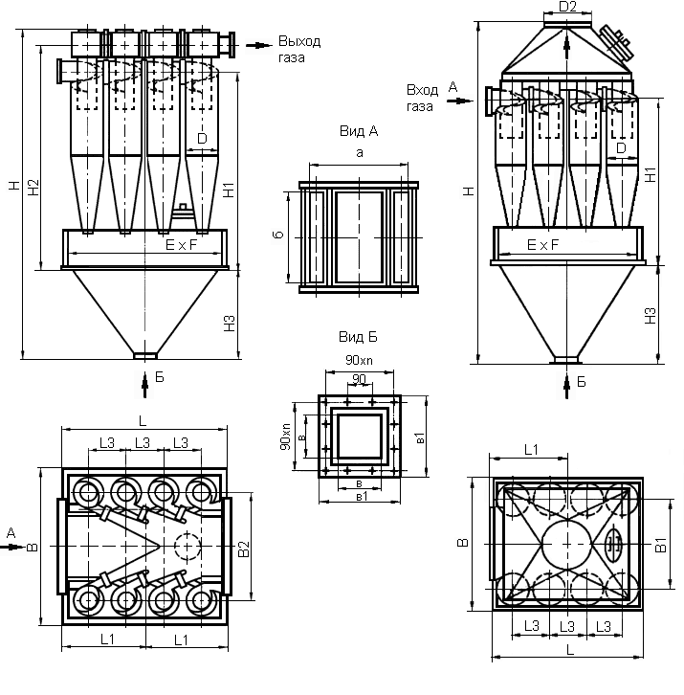

|  |  |  |  |  |  |  |  |  |  |
| --- | --- | --- | --- | --- | --- | --- | --- | --- | --- |
| Наименование | Q= м3/ч | L | B | H | H1 | H2 | H3 | D | D1 |
| ЦИКЛОН ЦН-15-500х8УП | 18160-21160 | 2300 | 2024 | 4366 | 2465 | 2860 | 1310 | 500 | 290 |
|  |
| ЦИКЛОН ЦН-15-750х8УП | 40800-47600 | 3322 | 2958 | 6850 | 3090 | 3605 | 1310 | 750 | 443 |  |
|  |
| ЦИКЛОН ЦН-15-800х8УП | 46400-54080 | 3468 | 3092 | 7204 | 3715 | 4349 | 2560 | 800 | 470 |  |
|  |
| ЦИКЛОН ЦН-15-500х8СП | 18160-21160 | 2300 | 2024 | 4900 | 2465 | - | 1310 | 500 | 290 |  |
|  |
| ЦИКЛОН ЦН-15-750х8СП | 40800-47600 | 3322 | 2958 | 7545 | 3090 | - | 1310 | 750 | 443 |  |
|  |
| ЦИКЛОН ЦН-15-800х8СП | 46400-54080 | 3468 | 3092 | 7920 | 3715 | - | 2560 | 800 | 470 |  |
|  |

|  |  |  |  |  |  |  |  |  |  |
| --- | --- | --- | --- | --- | --- | --- | --- | --- | --- |
| Наименование | Е | F | a | b | L1 | L3 | в | в1 | Масса, кг |
| ЦИКЛОН ЦН-15-500х8УП | 2150 | 1850 | 1188 | 340 | 1230 | 580 | 300 | 440 | 3032 |
|  |
| ЦИКЛОН ЦН-15-750х8УП | 2725 | 2375 | 1522 | 440 | 1545 | 730 | 300 | 440 | 6568 |  |
|  |
| ЦИКЛОН ЦН-15-800х8УП | 3300 | 2900 | 1856 | 538 | 1860 | 880 | 300 | 440 | 7376 |  |
|  |
| ЦИКЛОН ЦН-15-500х8СП | 2150 | 1850 | 1188 | 340 | 1230 | 580 | 300 | 440 | 3167 |  |
|  |
| ЦИКЛОН ЦН-15-750х8СП | 2725 | 2375 | 1522 | 440 | 1545 | 730 | 300 | 440 | 7052 |  |
|  |
| ЦИКЛОН ЦН-15-800х8СП | 3300 | 2900 | 1856 | 538 | 1860 | 880 | 300 | 440 | 7796 |  |
|  |