ТЕХНИЧЕСКИЕ ХАРАКТЕРИСТИКИ ЦИКЛОНОВ ЦН-15

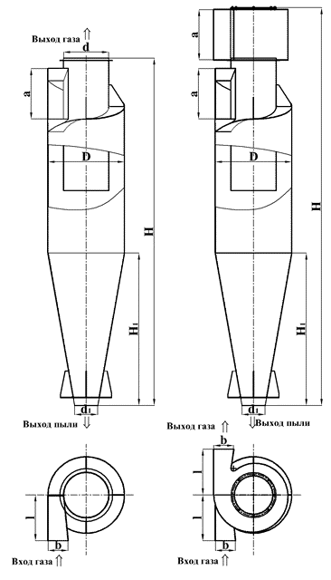

|  |  |  |  |  |  |  |  |  |  |
| --- | --- | --- | --- | --- | --- | --- | --- | --- | --- |
| Наименование | Q=м.куб/час | D | H | H1 | d | d1 | a/b | l | Масса, кг |
| ЦИКЛОН ЦН-15-300х1 | 828-954 | 300 | 1368 | 600 | 177 | 120 | 206/86 | 180 | 40 |
|  |
| ЦИКЛОН ЦН-15-400х1 | 1450-1691 | 400 | 1824 | 800 | 236 | 160 | 274/114 | 240 | 72 |  |
|  |
| ЦИКЛОН ЦН-15-450х1 | 1835-2141 | 450 | 2052 | 900 | 265 | 180 | 308/178 | 270 | 91 |  |
|  |
| ЦИКЛОН ЦН-15-500х1 | 2270-2645 | 500 | 2280 | 1000 | 295 | 200 | 340/140 | 300 | 112 |  |
|  |
| ЦИКЛОН ЦН-15-550х1 | 2740-3200 | 550 | 2508 | 1100 | 325 | 220 | 374/154 | 330 | 136 |  |
|  |
| ЦИКЛОН ЦН-15-600х1 | 3262-3810 | 600 | 2736 | 1200 | 354 | 240 | 406/166 | 360 | 162 |  |
|  |
| ЦИКЛОН ЦН-15-650х1 | 3825-4460 | 650 | 2964 | 1300 | 384 | 260 | 440/180 | 390 | 190 |  |
|  |
| ЦИКЛОН ЦН-15-700х1 | 4400-5180 | 700 | 3192 | 1400 | 414 | 280 | 472/192 | 420 | 220 |  |
|  |
| ЦИКЛОН ЦН-15-750х1 | 5100-5950 | 750 | 3420 | 1500 | 440 | 300 | 505/205 | 450 | 253 |  |
|  |
| ЦИКЛОН ЦН-15-800х1 | 5800-6740 | 800 | 3648 | 1600 | 472 | 320 | 538/218 | 480 | 288 |  |
|  |
| ЦИКЛОН ЦН-15-900х1 | 5700-9200 | 900 | 4104 | 1800 | 531 | 360 | 604/244 | 540 | 364 |  |
|  |
| ЦИКЛОН ЦН-15-1000х1 | 7100-11300 | 1000 | 4560 | 2000 | 590 | 400 | 670/270 | 600 | 450 |  |
|  |
| ЦИКЛОН ЦН-15-1200х1 | 10200-16200 | 1200 | 5472 | 2400 | 708 | 480 | 802/322 | 720 | 647 |  |
|  |
| ЦИКЛОН ЦН-15-1400х1 | 13900-22200 | 1400 | 6384 | 2800 | 826 | 560 | 934/374 | 840 | 881 |  |
|  |